Project: Analyze Customer Behavior
We are going to analyze the entire customer lifecycle: acquisition, conversion, customer activity, retention and churn.
acquisition is the stage when the customers learn more about the company's offerings from visits to the website, in an online business, this stage ends with customer registration on the website.
Conversion is the stage where customers purchase a product or service.
Retention. Now that a new customer has been acquired, the focus is to help the customer derive satisfaction and value from the product and services. In this stage, you can measure customer activity: how much they purchase, how often they use your product, etc.
The final stage in the customer lifecycle is customer churn. Inevitably, customers will stop using your product
Data Model
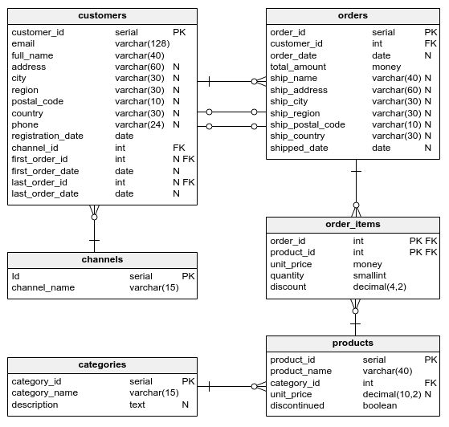
Explanation about relationship
- Customers and Orders: A customer can have many orders, but an order belongs to only one customer. This is represented by the foreign key customer_id in the orders table. [One-to-Many Relationships]
- Orders and Order Items: An order can have many order items, but an order item belongs to only one order. This is represented by the foreign key order_id in the order_items table. [One-to-Many Relationships]
- Products and Categories: A product belongs to only one category, but a category can have many products. This is represented by the foreign key category_id in the products table. [One-to-Many Relationships]
- Channels and Customers: A customer can register through multiple channels, and a channel can have many registered customers. [ Many-to-Many Relationships]
List of tables
- Customers
  - It contains information about customers.
  - It is used to store and manage customer details for communication, analysis, and order tracking.
- Orders
  - It contains details of customer orders.
  - It is used to track order details, including who placed the order, where it should be shipped, and the overall cost.
- order_items
  - It details the products included in each order.
  - To manage and track the specific products within an order, allowing for detailed analysis.
- Products
  - Contains information about the products available for sale.
- Categories
  - Contains information about product categories.
- Channels
  - Details the channels through which customers are acquired.
  - Example:
    - Social
    - Referral
    - Email
    - Paid search
    - Etc.
Description About Attributes
Customers
- customer_id
  - Unique identifier for each customer.
  - Type: int
- Email
  - The email address of the customer.
  - Type: String
- full_name
  - The full name of the customer.
  - Type: String
- Address
  - The customer's street address
  - Type: String
- City
  - The city where the customer resides.
  - Type: String
- Region
  - The region, state, or province where the customer resides
  - Type: String
- postal_code
  - The postal or ZIP code for the customer's address
  - Type: String
- Country
  - The country where the customer resides
  - Type: String
- Phone
  - The customer's phone number, used for communication and verification
  - Type: String
- registration_date
  - The date when the customer registered.
  - Type: Date
- channel_id
  - A reference to the channel through which the customer was acquired.
  - Type: Int (Foreign Key)
- first_order_id
  - The unique identifier of the customer's first order.
  - Type: int
- first_order_date
  - The date when the customer placed their first order.
  - Type: date
- last_order_id
  - The unique identifier of the customer's most recent order.
  - Type: int
- last_order_date
  - The date when the customer placed their most recent order.
  - Type: date
Orders
- order_id
  - A unique identifier for each order.
  - Type: int
- customer_id
  - References the unique identifier of the customer
  - Type: int (foreign key)
- order_date
  - The date when the order was placed.
  - Type: date
- total_amount
  - The total monetary value of the order.
  - Tyoe: decimal
- ship_name
  - The name of the person or entity to whom the order is being shipped.
  - Type: string
- ship_address
  - The street address where the order is to be delivered
  - Type: String
- ship_city
  - The city where the order is to be delivered
  - Type: string
- ship_region
  - The region, state, or province where the order is to be delivered
  - Type: String
- ship_postal_code
  - The postal or ZIP code for the shipping address
  - Type: string
- ship_country
  - The country where the order is to be delivered.
  - Type: string
- shipped_date
  - The date when the order was shipped.
  - Type: date
products
- product_id
  - A unique identifier for each product.
  - Type: int
- product_name
  - The name of the product.
  - Type: string
- category_id
  - References the unique identifier of the category.
  - Type: int
- unit_price
  - The price of a single unit of the product.
  - Type: decimal
- Discontinued
  - Indicates whether the product is still available for sale.
  - Type: tinyint
order_items
- order_id
  - A unique identifier for each order
  - Type: int
- product_id
  - References the unique identifier of the product being ordered.
  - Type: int
- unit_price
  - The price per unit of the product at the time of the order
  - Type: decimal
- quantity
  - The number of units of the product being ordered.
  - Type: int
- Discount
  - The discount applied to the product.
  - Type: decimal
categories
- category_id
  - A unique identifier for each category.
  - Type: int
- category_name
  - The name of the category.
  - Type: string
- Description
  - A detailed description of the category.
  - Type: text
channels
- Id
  - A unique identifier for each channel.
  - Type: int
- channel_name
  - The name of the channel.
  - Type: string
Questions
- How many customers registered in the first six months of 2017? Name the column registration_count.
SELECT
COUNT(*) registration_count
FROM CUSTOMERS
WHERE YEAR(registration_date) = 2017
AND month(registration_date) between 1 and 6;

- Show the number of registrations in the current week. Name the column registrations_current_week.
SELECT count(*) AS registration_current_week FROM customers
WHERE
YEAR(registration_date) = '2017' AND
week(registration_date) = week(curdate());

- Create a report containing the 2017 monthly registration counts. Show the registration_month and registration_count columns. Order the results by month.

SELECT
MONTH(registration_date) AS month,
COUNT(*) AS registration_count
FROM customers
WHERE YEAR(registration_date)=2017
GROUP BY MONTH(registration_date)
ORDER BY month

- Find the registration count for each month in each year. Show the following columns: registration_year, registration_month, and registration_count. Order the results by year and month.
SELECT
YEAR(registration_date) AS registration_year,
MONTH(registration_date) AS registration_month,
COUNT(*) AS registration_count
FROM customers
GROUP BY YEAR(registration_date), MONTH(registration_date)
ORDER BY registration_year,registration_month;

- Write an SQL query to find the number of customer registrations per year for each channel.
SELECT YEAR(registration_date) , ch.channel_name , count(*) registration_count
FROM channels ch
INNER JOIN customers c on c.channel_id = ch.id
GROUP BY year(registration_date), ch.channel_name
Order by YEAR(registration_date)

6.Write an SQL query to find the number of customer registrations
per year for organic search channel.

select
year(registration_date),
ch.channel_name ,
count(*) as total_customers
from channels ch
join customers c
on c.channel_id = ch.id
group by year(registration_date),ch.channel_name
having ch.channel_name = 'organic search'

7. Create a report to show the weekly counts of registration in 2017,
based on the customer country.
Show the following columns: registration_week, country, and
registration_count. Order the results by week.

select year(registration_date),
week(registration_date)as registration_week,
country,
count(*)as registration_count
from customers
where year(registration_date) = '2017'
group by year(registration_date),
week(registration_date),country
order by registration_week

8. Among customers registered in 2017,
show how many made at least one purchase
(name the column customers_with_purchase) and
the number of all the customers registered in 2017
(name the column all_customers).

select count(first_order_id) as customers_with_purchase,
count(*) as all_customers
from customers
where year(registration_date) = '2017';

9. Find the lifetime conversion rate among customers
who registered in 2017.
Show the result in a column named conversion_rate.
Round the result to four decimal places.

select round((sum(case when first_order_id is not null then 1
end )) /(count(customer_id)),4) as conv_rate
from customers
where year(registration_date)='2017'

10. Find the conversion rate for each customer channel.
Show the channel_name and conversion_rate columns.
Display the conversion rates as percentages rounded to two decimal places.

select ch.channel_name,
round(count(first_order_date)/count(*)*100,2) as conv_rate
from channels ch
join customers c
on c.channel_id = ch.id
group by channel_name
order by conv_rate

